**COLLEGE CODE : 3105**

**COLLEGE NAME : DHANALAKSHMI SRINIVASAN**

**COLLEG OF ENGINEERING AND**

**TECHNOLOGY.**

**DEPARTMENT : B.TECH INFORMATION**

**TECHNOLOGY**

**STUDENT NM-ID : 9bb6b241f18d4e79ec648e9c1bebf781**

**ROLL NO : 310523205021**

**DATE : 07.05.2025**

**Completed the project named as**

Personalization Marketing and Customer Experience

**SUBMITTED BY,**

**NAME : V.DEVADHARSHINI**

**MOBILE NO : 6381549340**

**Phase 4: Performance of the project**

**Title:** Personalization Marketing and Customer Experience

**Objective:**  
The goal of this phase is to optimize personalization strategies to enhance customer experience across digital platforms. The project focuses on tailoring product recommendations, dynamic content delivery, and adaptive user interfaces based on user behavior and preferences, ultimately boosting engagement, retention, and conversion rates.

**1. User Data Collection and Segmentation**

**Overview:**  
Data from multiple channels—website, app, CRM, and third-party analytics—will be unified to create detailed user profiles.

**Enhancements:**

* **Behavioral Analysis:** Use real-time user activity to adjust content dynamically.
* **Segmentation Models:** Implement AI-driven segmentation based on purchase history, browsing patterns, and engagement rates.

**Outcome:**  
Improved ability to deliver relevant messages to the right audience segment, increasing click-through and conversion rates.

**2. Personalization Engine Optimization**

**Overview:**  
Develop and fine-tune a machine learning engine to drive personalized experiences.

**Key Improvements:**

* **Recommendation Systems:** Optimize collaborative and content-based filtering algorithms.
* **Dynamic Content Delivery:** Automate landing page and email content personalization.

**Outcome:**  
Customers will receive hyper-personalized suggestions and content, leading to longer sessions and higher average order value.

**3. Omnichannel Experience Integration**

**Overview:**  
Ensure consistency of personalized experiences across web, mobile, email, and in-store channels.

**Key Enhancements:**

* **Unified Customer Profile:** Sync all user data sources in real-time.
* **Cross-Channel Syncing:** Maintain user state and preferences seamlessly across platforms.

**Outcome:**  
A unified brand experience that builds trust and encourages repeat engagement.

**4. Privacy and Compliance Optimization**

**Overview:**  
All personalization initiatives will comply with data privacy laws like GDPR and CCPA.

**Security Measures:**

* **Data Anonymization:** Personally identifiable information (PII) will be anonymized before processing.
* **Consent Management:** Build systems to capture and manage user consent dynamically.

**Outcome:**  
Trust is reinforced through transparent, privacy-compliant personalization strategies.

**5. Performance Testing and Feedback Loops**

**Overview:**  
Thorough testing will be conducted to measure the effectiveness of personalization strategies.

**Implementation:**

* **A/B Testing:** Compare different personalization levels across customer segments.
* **Metrics Monitoring:** Track bounce rate, time-on-site, conversion, and retention.
* **Feedback Loop:** Collect user feedback to refine personalization rules and machine learning models.

**Outcome:**  
The marketing system will become increasingly effective and customer-centric over time.

**Key Challenges and Solutions**

1. **Data Silos**
   * *Challenge:* Disconnected data across departments
   * *Solution:* Implement a centralized Customer Data Platform (CDP)
2. **Overpersonalization**
   * *Challenge:* Making users feel "tracked"
   * *Solution:* Balance personalization with subtlety and transparency
3. **Scalability**
   * *Challenge:* Real-time personalization at scale
   * *Solution:* Use cloud-based architectures and edge computing for speed

**Outcomes of This Phase**

* Increased customer engagement and satisfaction
* Better ROI from marketing campaigns
* Enhanced brand loyalty through tailored experiences
* Strengthened data governance and compliance

**Next Steps**

Deploy system-wide personalization, gather long-term user feedback, and iterate on algorithms for more nuanced customer experiences before full-scale rollout.

**PROGRAM:**

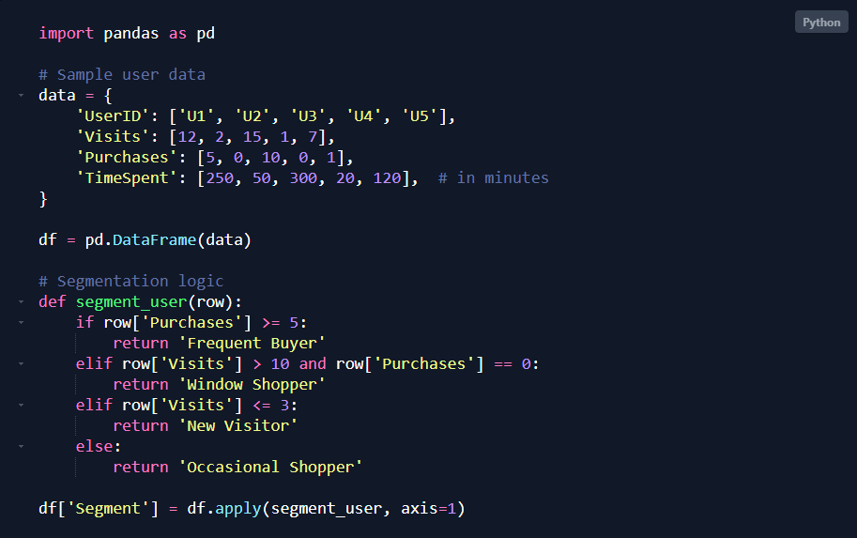

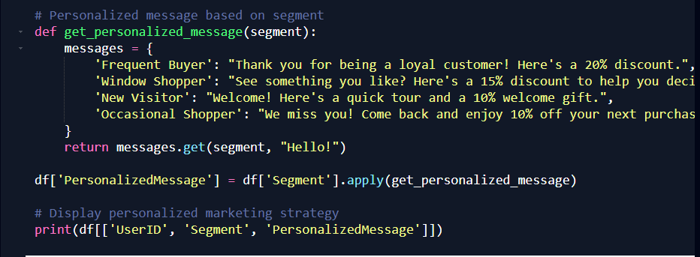

**PYTHON** **OUTPUT:**

